C

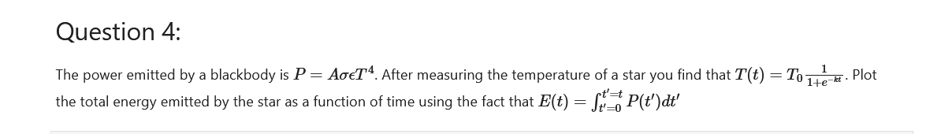

#here there is no direct connection energy and power,

So we use a trick

1. Make dimensionless equation that is:
2. p/a*(sigma)*(epsilon)=t^4
3. substitute this value of t in temperature relation that is:
4. p/a*(sigma)*(epsilon)*T^4(not)=(1/exp^(-kt))^4

#here k is also unknown so lets treat kt as variable

Code

……………

import numpy as np

import matplotlib.pyplot as plt

kt=np.linspace(0,3,100)

p=(1/(1+np.exp(-kt)))**4 #dimensionless

E=np.cumsum(p)*(kt[1]-kt[0]) #integration

plt.plot(kt,p,label='power')

plt.plot(kt,E,label='energy')

plt.xlabel('$kt$',fontsize=20)

plt.ylabel(r'$\left(\frac{k}{A \sigma \epsilon T_0^4}\right) E(kt) ::or :p(kt)$', fontsize=20)

plt.legend()

plt.show()

……………………………………………………..